**America University of Beirut**

Department of Mechanical Engineering

**MECH 642**

Computer Vision

**Assignment 1: Camera Calibration**.

**Professor Daniel Asmar**

Fall 2021\2022

Presented by:

Jawad Haidar 202125161

Rabab Kawtharani 202222252

Rafic Al Ayass 201800563

Contents

Introduction 3

Methodology 4

Direct Linear Transformation 4

Feature Extraction 4

Linear Estimation of the Camera Projection Matrix 5

Recover Intrinsic and Extrinsic Parameters from P 5

Plane Based Technique: Zhang’s Method 7

**Results** 7

# Introduction

Camera calibration is a crucial step in computer vision. It aims to finding the geometric parameters that are known as extrinsic and intrinsic parameters.

Extrinsic parameters, as their name shows, are the parameters that are not directly related to the camera itself. However, they are external parameters describing the camera pose. These parameters communicate the transformation ([R t] which consists of rotation and translation in the considered case of perspective projection) happening between the frame of the real world in 3D and the image frame in 2D.

On the other hand, the intrinsic parameters are internal characteristics of the camera itself. These parameters include the focal length (f) accounting for the scale factor (α and β), the optical center ($u_{0} and x_{0})$, and the skew coefficient $(γ=cotθ)$.

In this report, calibration of a camera using two methods is discussed. The Direct Linear Transformation (DLT) uses a 3D apparatus while Zahng’s method needs a 2D plane. MATLAB was used to apply camera calibration techniques. Both approaches and their corresponding results are discussed in the report below.

# Methodology

This section discusses the two approaches used to perform camera calibration: the Direct Linear Transformation (DLT), and the Plane based technique proposed by Zhang.

## Direct Linear Transformation

For this method, a 3D reference object was built. This calibration apparatus consists of three orthogonal planes with checkerboard pattern printed onto them (fig.1). The checkerboard used here has 1cm*1cm checkered pattern.

Figure : Checkerboard 3D Structure

A world coordinate frame was attached to the checkerboard orthogonal system as demonstrated in the figure below:

z

x

y

Figure : World Frame Alignment

This 3D structure is crucial to find the relation between a set of points in the world frame and their correspondence in the obtained 2D image.

### Feature Extraction

Feature extraction reflects Corner Detection and Correspondence. Using Harris-Stephen’s algorithm built in MATLAB’s computer vision toolbox on the grayscale image of the 3D system. So, after the image was loaded to MATLAB, it was turned into grayscale (fig.3) then subjected to corner detection. This function detected points and returned their coordinates of which 40 points were selected. The extracted points are shown in the fig. 4:

Figure : Points Selection

Then, the correspondence matrix was filled manually with the coordinates of the equivalent point in the world frame based on the known locations of the points and the known dimensions of the checkered pattern.

### Linear Estimation of the Camera Projection Matrix

After establishing the correspondence, the camera calibration matrix was estimated using the following equation:

equation 1: $p=ϺP$,

where is the augmented vector of coordinates of the points in 2D, P is the augmented vector of coordinates of points in 3D, and $Ϻ$ is the calibration matrix defines as follows:

equation 1.1: $Ϻ=\left[\begin{matrix}α & γ & u_{0} \\ 0 & β & v_{0} \\ 0 & 0 & 1\end{matrix}\right]\left[\begin{matrix}R & t\end{matrix}\right]=ρ\left[\begin{matrix}A & b\end{matrix}\right]$,

where **R** is the rotation matrix, t or b is the translation matrix, and $ρ$ is a scaling factor.

Now, given the established 2D-3D correspondence and equation 1, two equations, for each point, were found and presented in the form of the following matrix:

$$Pm=\left[\begin{matrix}X_{i} & Y_{i} & Z_{i} & 1 \\ 0 & 0 & 0 & 0\end{matrix} \begin{matrix}0 & 0 & 0 & 0 \\ X_{i} & Y_{i} & Z_{i} & 1\end{matrix} \begin{matrix}-u_{i}X_{i} & -u_{i}Y_{i} & -u_{i}Z_{i} & {-u}_{i} \\ -v_{i}X_{i} & -v_{i}Y_{i} & -v_{i}Z_{i} & -v_{i}\end{matrix}\right]$$

To find the intrinsic and extrinsic parameters, Pm=0 was solved using the homogeneous liner least square method which yields to $P^{T}P$ whose solution is the eigen vector associated with the smallest eigenvalue obtained after eigenvalue decomposition.

Now that $Ϻ$ was obtained, A, defined in equation 1.1, was found from the columns of $Ϻ.$

### Recover Intrinsic and Extrinsic Parameters from P

Having obtained A, the intrinsic parameters are now easily obtained using the equations that follow:

equation 2.1: $ρ=\frac{ε}{\left|a_{3}\right|}$

equation 2.2: $u_{0=}ρ^{2}a_{1}a_{3}$

equation 2.3: $v_{0=}ρ^{2}a_{2}a_{3}$

equation 2.4: $θ=\cos^{-1}\left(-\frac{(a_{1} x a_{3}).(a_{2} x a_{3})}{\left|a_{1} x a_{3}\right|.\left|a_{2} x a_{3}\right|}\right)$

equation 2.5: $α=ρ^{2}\left|a_{1} x a_{3}\right|\sin{θ}$

equation 2.6: $β=ρ^{2}\left|a_{2} x a_{3}\right|\sin{θ}$

The extrinsic parameters were calculated based on the following equations:

equation 3.1: $r_{1}=\frac{ρ^{2}\sin{θ}}{β}=\frac{1}{\left|a_{2} x a_{3}\right|}(a_{2} x a_{3})$

equation 3.2: $r_{2}=r_{3} x r_{1}$

equation 3.3: $r_{3}=ρa_{3}$

Then, Κ was defined as shown in equation 3.4:

equation 3.4: $Κ=\left[\begin{matrix}α & -α\cot{θ} & u_{0} \\ 0 & \frac{β}{\sin{θ}} & v_{0} \\ 0 & 0 & 1\end{matrix}\right]$

Knowing that $Κt=ρb$, the equation for t (translation vector between the world frame and the image plane) was demonstrated as follows:

equation 3.5: $t=ρΚ^{-1}b$

So, using the DLT method, the intrinsic and extrinsic parameters were obtained. This approach is summed up in the following flowchart:

Figure : DLT Method Flowchart

## Plane Based Technique: Zhang’s Method

In this method, there is no need to build a 3D structure. Zhang supposed the usage of checkered pattern on a 2D plane. In this case, the Z of the world coordinate system is zero. This method was applied based on the steps that discussed below.

### 2D Checkered Plane

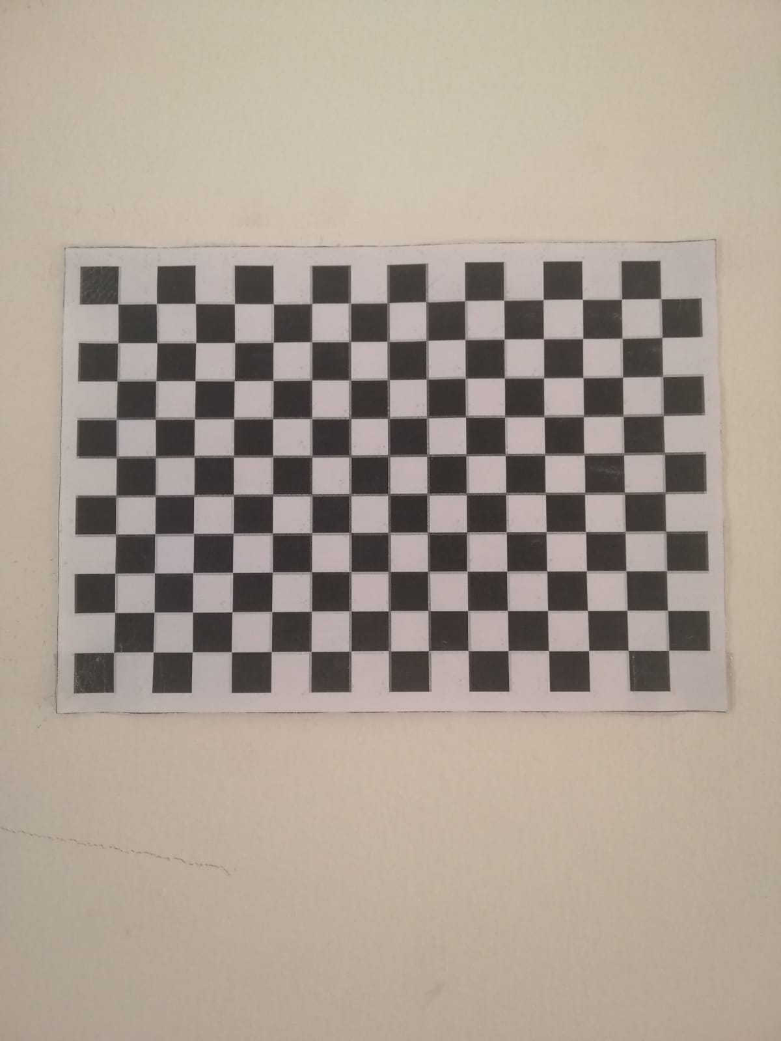 A 2D plane with 11*16 checkered pattern was printed. The squares on the board are all 1cm*1cm (fig.6). Twenty pictures were taken of the board in extreme variations of view.

Figure : 2D Checkerboard

### Features Extraction

All 20 images (attached with the files) where loaded into MATLAB then turned into grayscale. After that, an algorithm was written to extract features from all the images and save them into separate cells. The function used for features extraction is built in MATLAB computer vision toolbox and is called “detectCheckerboardPoints”. This function returned the size of the checkerboard (11*16) and the coordinates of all the detected corners in the form of M*2 matrix. In this case, M is equal to 150 ((11-1) *(16-1)) corners. The matrices of all images were created at once and stored in separate cells indexed by the number of the image (from 1 to 20).

Now that the features are extracted, their corresponding values in the world frame were automatically generated based assigning the system on the top left corner of the board, as shown in fig. 7, and on a simple algorithm. Since the square size is 1*1, it was easy to generate a world frame coordinate matrix for the 150 points directly. This 150*2 matrix that has the X and Y coordinates of the corners was saved to be used as correspondence for all the points extracted from the 20 images. These are called homographs and are defined by equation 4,1.

y

x

Figure : 2D Checkerboard with World Coordinate System

equation 4,1: $λp=HP$

where p is the augmented coordinates of the points in the image plane, P is the augmented coordinates of the points in the world coordinate system, H is 3*3 homography matrix, and λ is an arbitrary scalar.

### Constraints on the Intrinsic Parameters

We can write H in the form shown in equation 4.2 below where $r_{i}$ are columns of the rotation matrix R.

equation 4.2: $H=A\left[\begin{matrix}r_{1} & r_{2} & t\end{matrix}\right]\left[\begin{matrix}X \\ Y \\ 1\end{matrix}\right]$

where $r_{3}$ is canceled out by the effect of Z=0. This yield to put constraints on the intrinsic parameters shown in the equations below:

equation 4.3: $h_{1}^{T}A^{-T}A^{-1}h_{2}=0$

equation 4.4: $h_{1}^{T}A^{-T}A^{-1}h_{1}=h_{2}^{T}A^{-T}A^{-1}h_{2}$

### Closed Form Solution

We have a symmetric matrix B defined by 6D vector

${b=\left[\begin{matrix}B_{11} & B_{12} & B_{22} & B_{13} & B_{23} & B_{33}\end{matrix}\right]}^{T}$, with $B_{11}=\frac{1}{α^{2}}$, $B_{12}=\frac{-γ}{α^{2}β}$, $B_{22}=\frac{γ^{2}}{α^{2}β^{2}}+\frac{1}{β^{2}}$, $B_{13}=\frac{v_{0}γ-u_{0}β}{α^{2}β}$, $B_{23}=-\frac{γ(v_{0}γ-u_{0}β)}{α^{2}β^{2}}-\frac{v_{0}}{β^{2}}$, and $B_{33}=\frac{{(v_{0}γ-u_{0}β)}^{2}}{α^{2}β^{2}}+\frac{{v_{0}}^{2}}{β^{2}}+1$.

This enables us to write $h_{i}^{T}Bh_{j}=v_{ij}^{T}b$, where v is defined based on equation 4.5.

equation 4.5:

$$v_{ij}={\left[\begin{matrix}h_{i1}h_{j1} & h_{i1}h_{j2}+h_{i2}h_{j1} & h_{i2}h_{j2} & h_{i1}h_{j3}+h_{i3}h_{j1} & h_{i3}h_{j2}+h_{i2}h_{j3} & h_{i3}h_{j3}\end{matrix}\right]}^{T}$$

Then we obtain 2 homogeneous equations in b stated in equation 4.6.

equation 4.6: $\left[\begin{matrix}v_{12}^{T} \\ {(v_{11}-v_{22})}^{T}\end{matrix}\right]b=0$

Now that $Vb=0$, the solution is the eigen vector associated with the smallest eigenvalue of $V^{T}V$.

### Calculating Intrinsic and Extrinsic Parameters

Now that the solution is established and B is found, the intrinsic parameters were calculated as follows:

equation 5.1: $v_{0}=\frac{{(B}_{12}B_{13}-B_{11}B_{23})}{{(B}_{11}B_{22}-{B_{12}}^{2})}$

equation 5.2: $λ=B_{33}-[{B_{13}}^{2}+v_{0}\left(B_{12}B_{13}-B_{11}B_{23}\right)]/B_{11}$

equation 5.3: $α=\sqrt{λ/B_{11}}$

equation 5.4: $β=\sqrt{\frac{λ}{B_{11}}/}{(B}_{11}B_{22}-{B_{12}}^{2})$

equation 5.5: $γ=-$ $B_{12}α^{2}β/ λ$

equation 5.6: $u_{0}=\frac{γv_{0}}{β}-B_{13}α^{2}/ λ$

The extrinsic parameters were calculated as follows:

equation 5.7: $r_{1}= λA^{-1}h_{1}$

equation 5.7: $r_{2}= λA^{-1}h_{2}$

equation 5.7: $r_{3}=r_{1}x r_{2}$

equation 5.7: $t= λA^{-1}h_{3}$

# Results

Applying these algorithms into MATLAB for the two methods returned the following results.

## DLT Results

**The Intrinsic Matrix:**

$$Κ=\left[\begin{matrix}1173 & 6 & 593 \\ 0 & 1179 & 772 \\ 0 & 0 & 1\end{matrix}\right]$$

**The Transformation Matrix:**

M= $\left[\begin{matrix}0.0016 & -0.0015 & -0.0038 & 0.608 \\ 0.000043 & -0.0047 & 0.00051 & 0.7938 \\ -0.0000019 & -0.000002 & -0.000017 & 0.000098\end{matrix}\right]$

**The average reprojection error:**

We got great accuracy, with only +/- 0.94 pixels and +/- 1.14 pixels as errors in x and y direction respectively.

## Zhang’s Method Results

**The Intrinsic Matrix:**

$$Κ=\left[\begin{matrix}0.0021 & 0 & 0 \\ 0 & 0.0022 & 0.05 \\ 0 & 0 & 1\end{matrix}\right]$$

**The transformation Matrix:**

The transformation matrix for each image is found in the code.

**The average reprojection error:**

We got great accuracy, with only +/- 0.56 pixels and +/- 0.6415 pixels as errors in x and y direction respectively.

# References

Zhengyou Zhang. A flexible new technique for camera calibration

Z. Zhang, “Camera Calibration”, chapter 2, page 4-43, in G. Medioni and S.B. Kang, eds, Emerging Topics In Computer Vision, Prentice Hall Professional Technical Conference, 2004.